**Assignment 10**

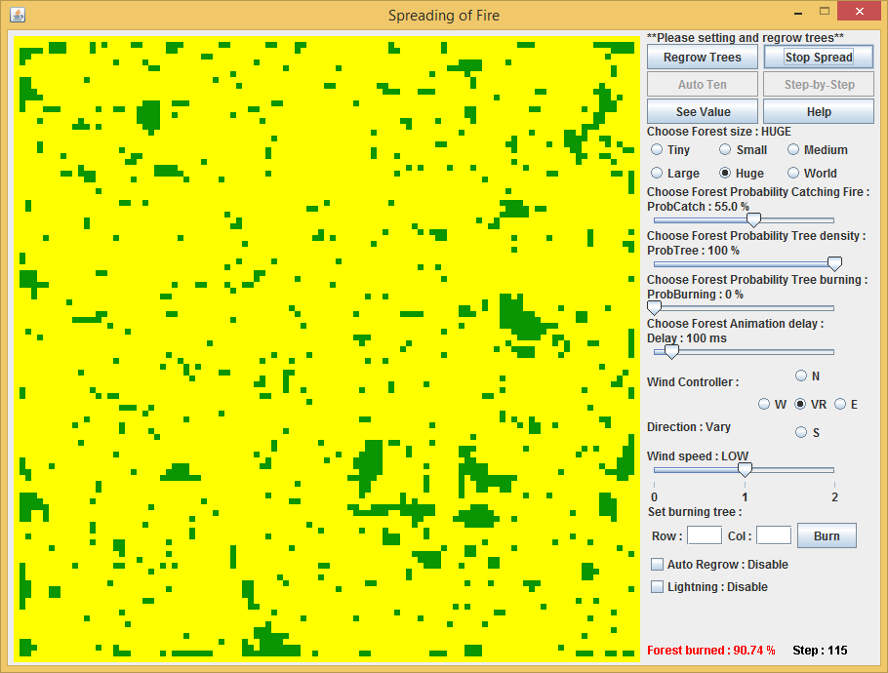**b. With a wind level of LOW (1) and a fixed probTree, vary wind direction and through animations observe the effects on the forest burn. Discuss the results.**

Forest size 107 x 107 cells (trees)

Set ProbCatch 55 %

Set ProbTree 100 %

Set ProbBurning 0 %

Set disable automatic regrow tree

Set disable lightning function

**Result:** - Forest burned 90.74 %  
 - Spread fire 115 steps

**Comment:** Vary wind direction and low wind speed is less affect the result of the simulation.

**c. Develop a program to run three experiments with wind levels of NONE = 0, LOW = 1, and HIGH = 2. Have fixed wind direction and probTree. The program should conduct each experiment 10 times. Also, have the code determine the average percent burned for each level. Discuss the results.**

1. Wind speed = NONE

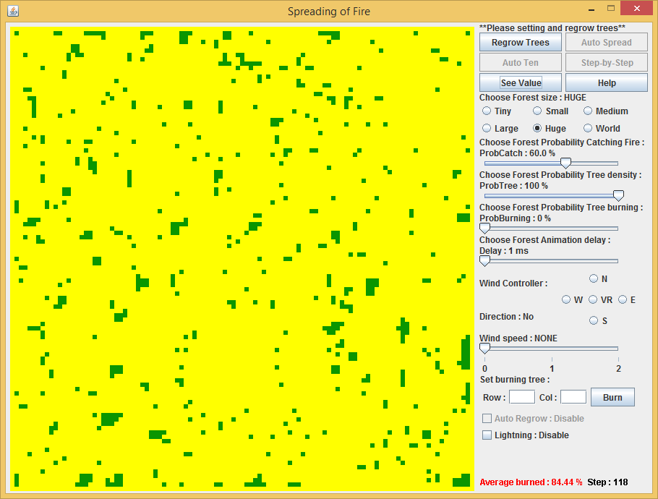

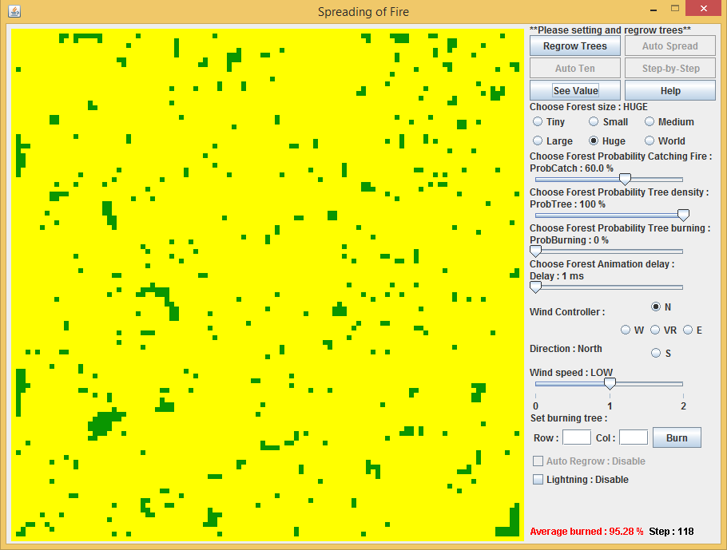2. Wind speed = LOW

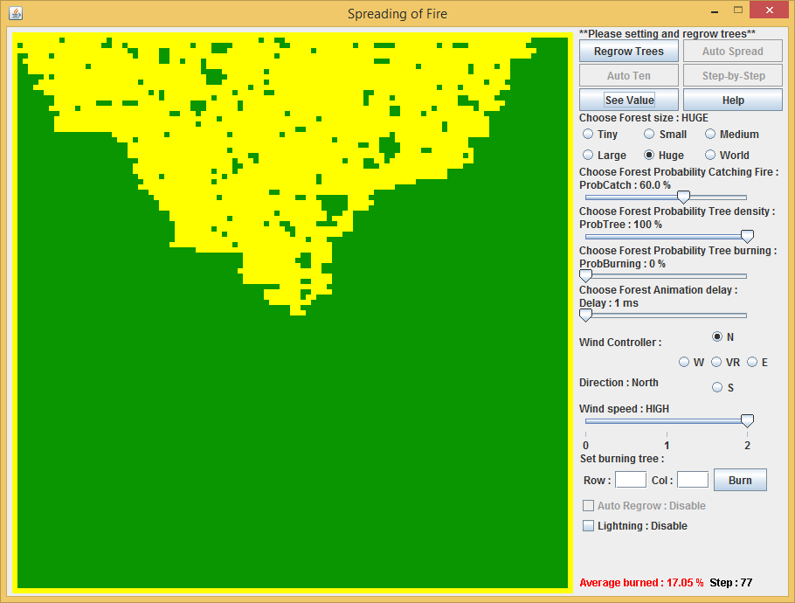3. Wind speed = HIGH

Forest size 107 x 107 cells (trees)

Set ProbCatch 60 %

Set ProbTree 100 %

Set ProbBurning 0 %

Set Direction = North

Set disable automatic regrow tree

Set disable lightning function

**Result:** 1. Wind speed = NONE

- Forest burned 84.44 %

2. Wind speed = LOW

- Forest burned 95.28 %

3. Wind speed = HIGH

- Forest burned 17.05 %

**Comment:** The result of wind speed ‘NONE’ and ‘LOW’ looks similar, but totally different when wind speed ‘HIGH’.

**d. Develop a program to run eight experiments with no wind and probTree = 10%, 20%, 30%, …, and 90%. The program should conduct each experiment ten times. Also, have the code determine the average percent burned for each probability. Plot the data and fit a curve to the data. Discuss the results.**

1. ProbTree = 10 %

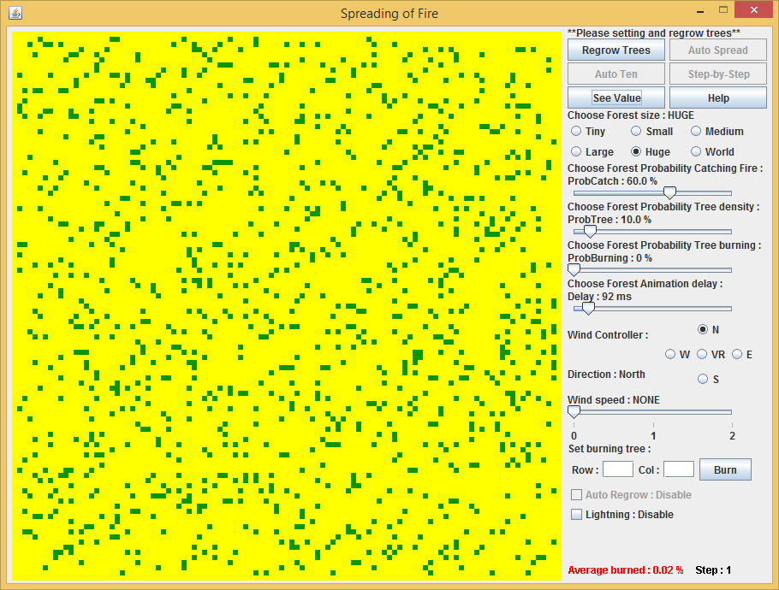

2. ProbTree = 20 %

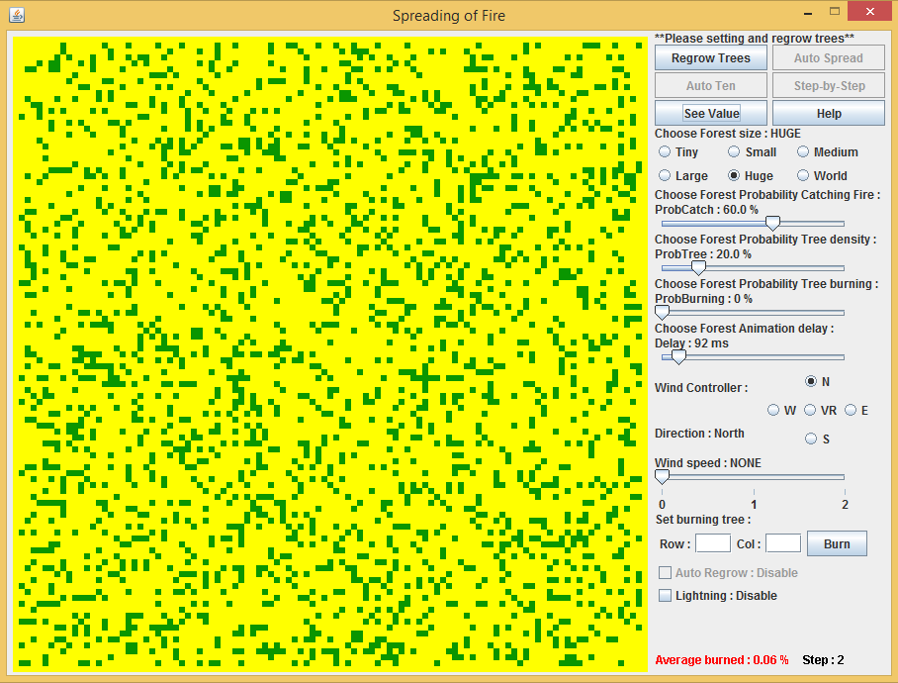

3. ProbTree = 30 %

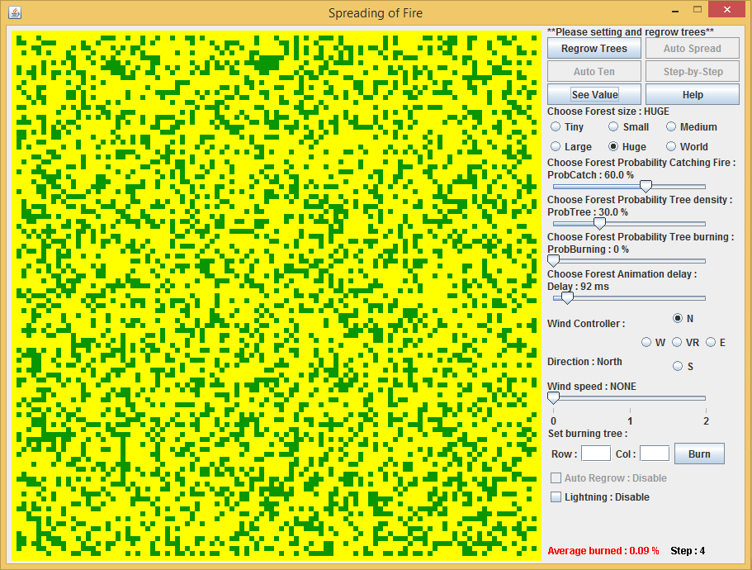

4. ProbTree = 40 %

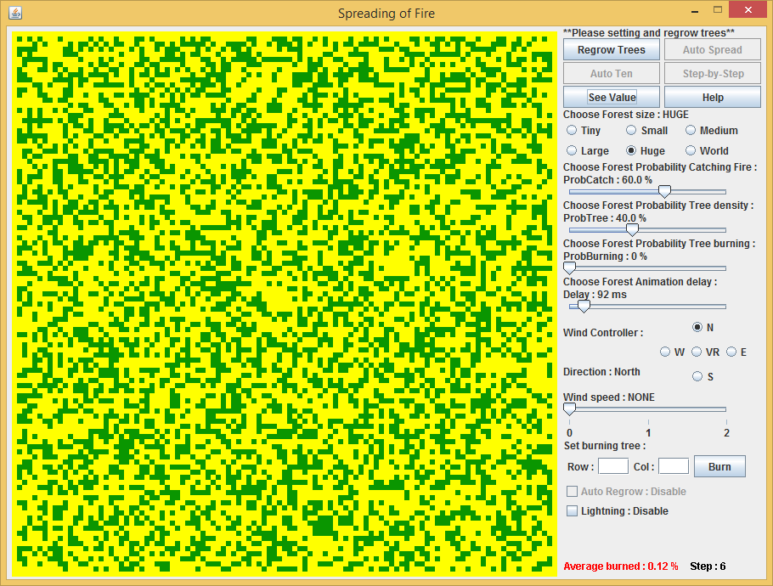

5. probTree = 50 %

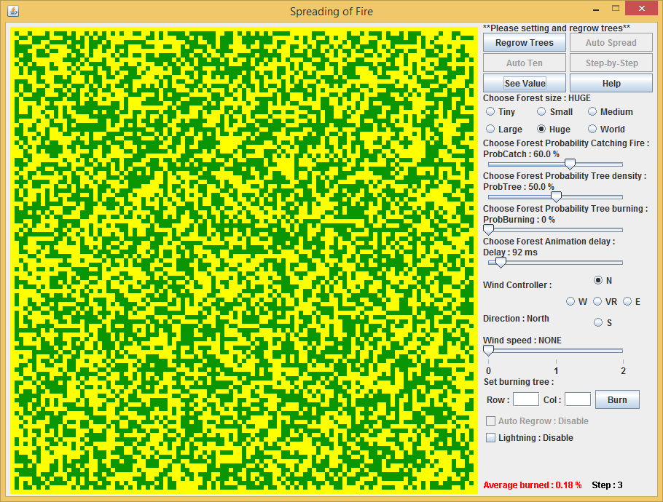

6. probTree = 60 %

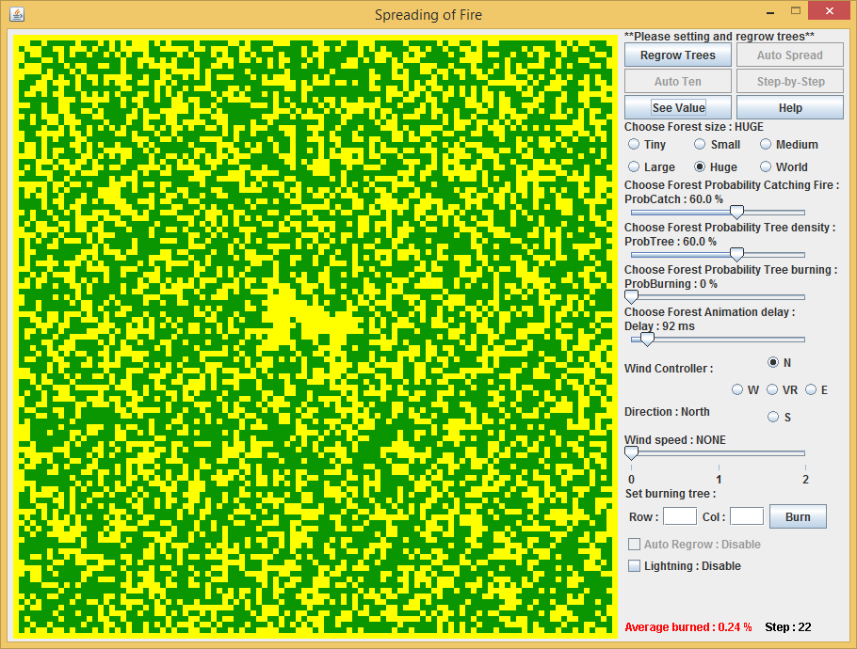

7. probTree = 70 %

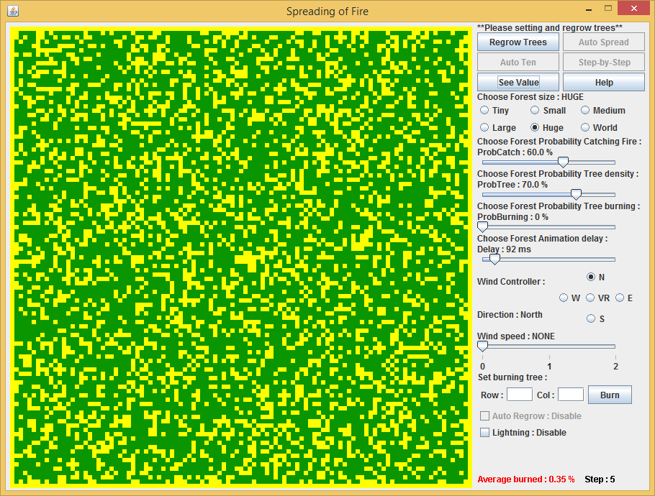

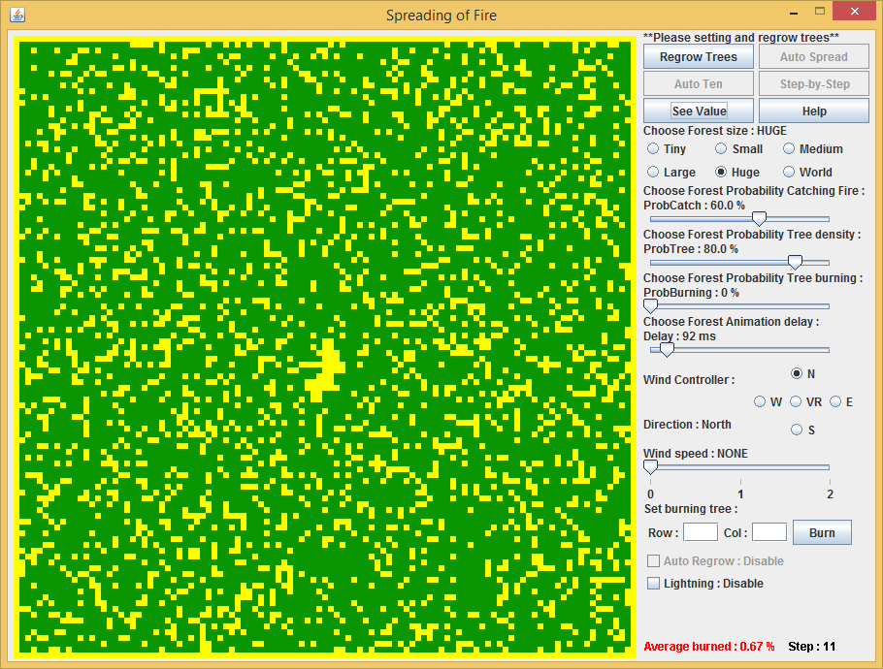8. probTree = 80 %

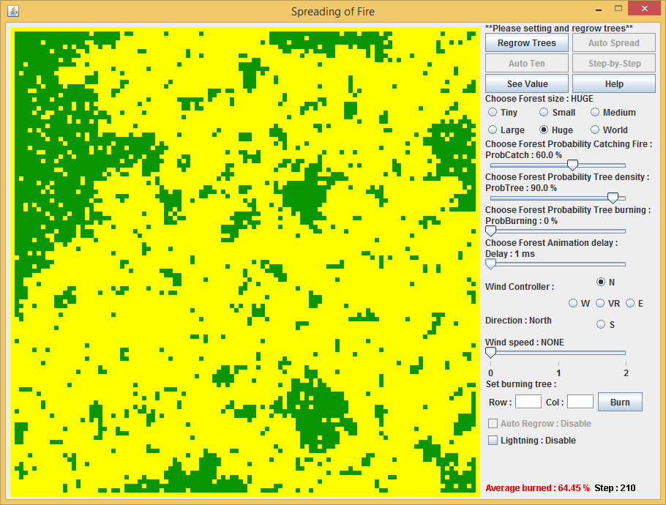9. probTree = 90 %

Forest size 107 x 107 cells (trees)

Set ProbCatch 60 %

Set ProbBurning 0 %

Set no wind direction and speed

Set disable automatic regrow tree

Set disable lightning function

**Result:** 1. ProbTree = 10 %

- Forest burned 0.02 %

2. ProbTree = 20 %

- Forest burned 0.06 %

3. ProbTree = 30 %

- Forest burned 0.09 %

4. ProbTree = 40 %

- Forest burned 0.12 %

5. ProbTree = 50 %

- Forest burned 0.18 %

6. ProbTree = 60 %

- Forest burned 0.24 %

7. ProbTree = 70 %

- Forest burned 0.35 %

8. ProbTree = 80 %

- Forest burned 0.67 %

9. ProbTree = 90 %

- Forest burned 64.45 %

**Comment:** The percentage of forest burned will increase according to the number of trees in the forest.